
Media Contact:
Sarah Wynn Benton
BRAVE Public Relations
404.233.3993
sbenton@emailbrave.com

FOR IMMEDIATE RELEASE

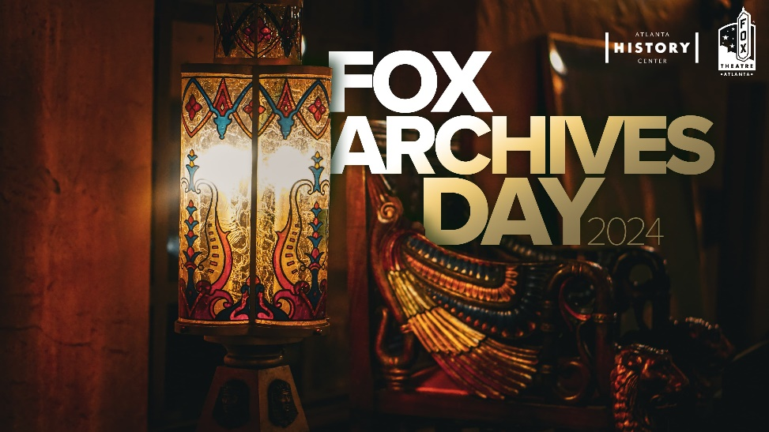
The Fox Theatre and Atlanta History Center to Host Third Fox Theatre Archives Day on June 23

Atlanta, GA – (May 30, 2024) The Fox Theatre, in collaboration with the Atlanta History Center, is delighted to announce the third annual Fox Theatre Archives Day, taking place on Sunday, June 23, 2024, at 3 p.m. in the Grand Salon and Egyptian Ballroom at the Fox Theatre, located at 660 Peachtree Street NE, Atlanta, GA 30308. Tickets are on sale now and available for $54, plus applicable fees at foxtheatre.org.

This special event celebrates the Fox Theatre's rich history and cultural significance, offering attendees a unique opportunity to explore archival materials, artifacts and furniture that share the 95-year history of this iconic Atlanta landmark. Through this annual behind-the-scenes event, attendees will gain a deeper understanding and appreciation for the theatre's storied past and ongoing contribution to Atlanta.

The afternoon event will feature five archival stations where guests can preview original Metropolitan Opera programs with Paul Crater, recent acquisitions with Jody Thompson, original furniture as curated by Debra Freer and the “Best of Broadway” historic posters with Josh Kitchens. The afternoon program begins with two introductory presentations from Ms. Freer and Mr. Crater. This year, introductory tours of the mezzanine level of the theatre and its historic auditorium will be included.

###

About Joshua Kitchens
Joshua Kitchens is currently the director of archival services and digital initiatives for the Georgia Public Library Service. Josh previously served as the director of archives and information studies programs at Clayton State University. He was responsible for managing the program and teaching various courses, including Law and Records, Digital Preservation, and many others. Before working at Clayton State, Josh was an archivist for special collections at the Georgia College Ina Dillard Russell Library. He was responsible for digital collections, the library’s institutional repository known as the Knowledge Box, and university archives. Josh serves as an ongoing consultant for the Fox Theatre Archives.

About Jody Thompson
Jody Thompson is the Head of the Archives, Records Management & Digital Curation department and the Library’s Preservation Manager at the Georgia Institute of Technology. She holds a B.A. and M.A. in History from Georgia Southern University. Thompson provides strategic leadership and management of the department. This is Ms. Thompson’s first year participating in Fox Archives Day.

About Paul Crater
Paul Crater manages the Kenan Research Center at the Atlanta History Center. He is the author of three books on the history of Atlanta, including Baseball in Atlanta, World War II in Atlanta, and co-author of Lost Atlanta. He is the curator of Voices Across the Color Line, an award-winning exhibition of the Atlanta Student Movement that appeared at the Atlanta History Center in 2010. In 2014, he was awarded an Emmy for his contribution in the development of 37 Weeks: Sherman on the March, which aired on Georgia Public Broadcasting. He is a graduate of the University of Tennessee, Knoxville and Georgia State University.

About Debra Freer
Debra Freer is a distinguished professional appraiser specializing in fine art, antiques, and historical items. A published author, historian, archivist, and former museum curator, she has worked with many historic collections including the Fox Theatre. She presented "Appraising Historic Collections" at the 2008 national conference for the League of Historic American Theatres (LHAT). She was professionally trained and educated in appraisal studies and the decorative arts at institutions such as Christie's. From her non-fiction writing, such as in the NY Times bestseller, Lost Laysen, Debra Freer is known internationally as an authority on the life of Margaret Mitchell (Atlanta author of Gone with the Wind). Currently, she is an appraiser with Aaron Appraisal Services in Atlanta, Georgia.

About the Fox Theatre
The Fox Theatre is one of Atlanta's premier venues for live entertainment, welcoming more than 250 performances a year in its 4,665-seat theatre. From concerts to ballets, comedy, and movies, the historic venue attracts more than 500,000 visitors annually. The theatre hosts over 100 annual private events like wedding receptions, trade shows, corporate meetings, and association functions in two fabulous ballrooms. The Fox’s premium Marquee Club, presented by Lexus, is a 10,000 sq. ft, three-story luxury bar accessible to all Club Level ticket holders or annual members of the Fox Theatre. As a 501(c)(3) nonprofit arts organization, the Fox Theatre is a fiercely protected landmark and nationally acclaimed theatre today. The Fox Theatre proudly acknowledges its partners' generous support: Coca-Cola, Georgia Natural Gas, Georgian Terrace Hotel & Livingston Restaurant, Humana, Lexus, Northside Hospital, and Regions Bank. Tickets for all events are available at FoxTheatre.org, or toll-free at 855-285-8499. Stay connected by following the Fox Theatre on social via @theFoxTheatre on Instagram, Twitter, and Facebook.
Notable accolades include 2023 Billboard Magazine #2 Highest Grossing Theatre Worldwide (5,000 seats or less); 2023 VenuesNow Magazine #2 Year-End Top Stops (2,001-5,000 seats); 2022 IEBA Theatre of the Year; 2021 Billboard Magazine #1 Highest Grossing Theatre Worldwide (5,000 seats or less); 2021 Pollstar Magazine #2 Theatre Worldwide in Ticket Sales and 2021 VenuesNow Magazine #2 Year-End Top Stops (2,001-5,000 seats). Additionally, in 2019, the Fox Theatre was honored with the VenuesNow #1 Top Stop of the Decade Award for Tickets Sold, further cementing its reputation as a premier entertainment venue.
About Atlanta History Center
Founded in 1926, Atlanta History Center is an all-inclusive, 33-acre destination featuring the Atlanta History Museum, one of the nation’s largest history museums, including Cyclorama: The Big Picture experience; three historic houses—the 1920s Swan House, the 1860s Smith Farm, and the 1830s Wood Cabin; Goizueta Gardens; Kenan Research Center; the Grand Overlook Ballroom; a museum shop; Souper Jenny café; and BRASH coffee shop. In addition, Atlanta History Center owns and operates Atlanta History Center Midtown, which includes Margaret Mitchell House, gallery space, and event spaces. Atlanta History Center Midtown is currently closed. For more information, visit AtlantaHistoryCenter.com

